**Q5. Explain z-index, with a example.**

Z-index is a CSS property which controls the stacking order of elements in CSS. Higher the value of z-index the more the front the element comes. I works with respect to z-axis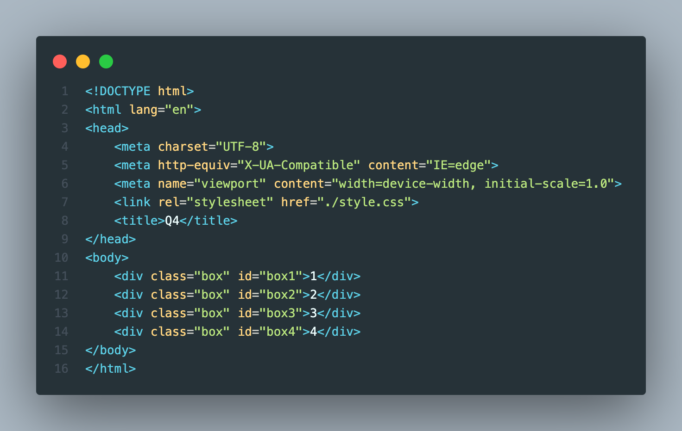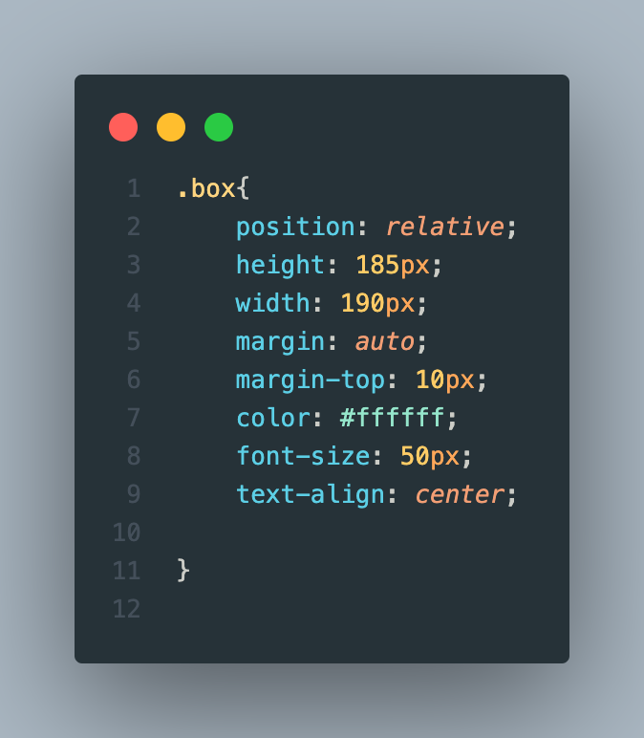

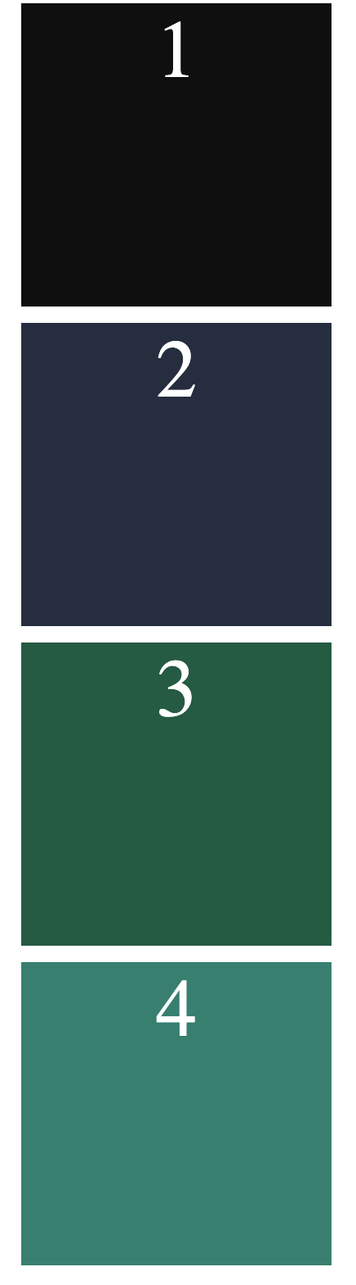

* When the position is relative all the div elements are stacked up on each other since it has display of block property.
* They go with normal flow just like other elements.
* Lets see what happens when the position is changed to Absolute in order to understand z-index property.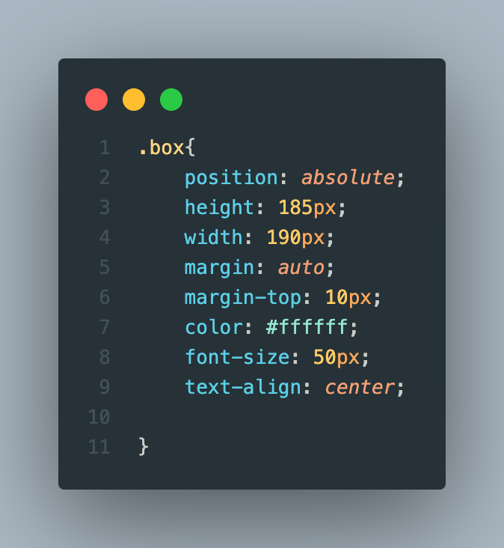

* The elements are stacked on each other and are overlapped on each other.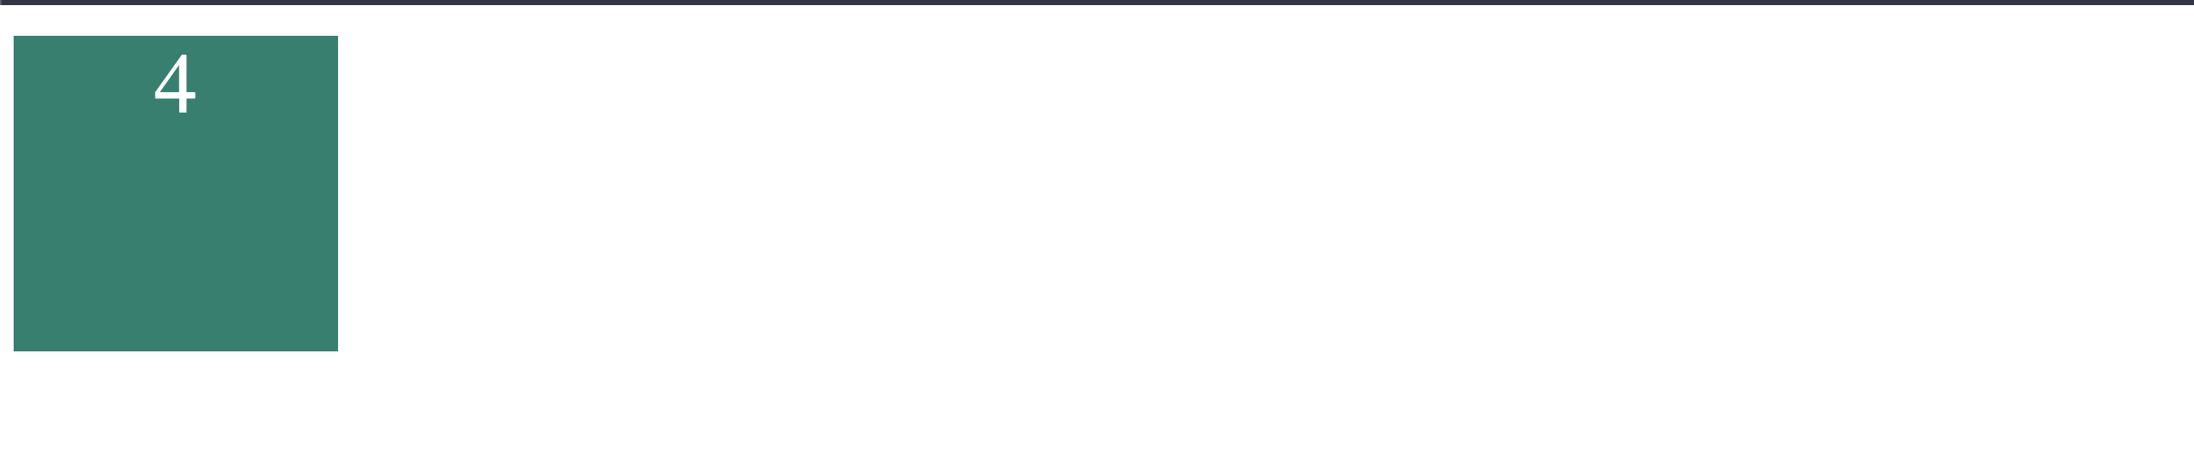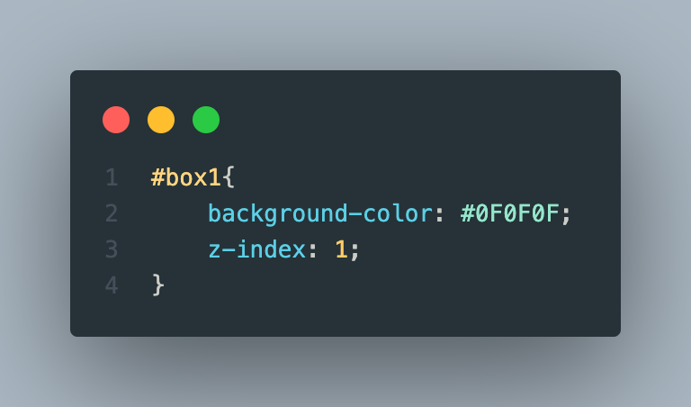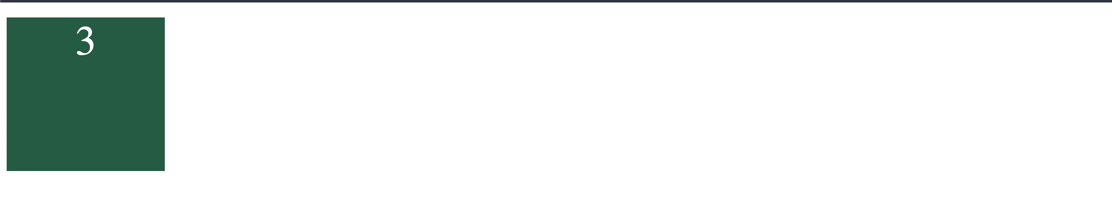
* Value of #box1 z-index at this moment is high hence it pushed at the top.